7.1.1 Sales Order Maintanance / manuály processed order

Ord. (sales order number) = will be automatically added by QAD by pressing enter.
Sold To (Sold to party) = search via magnifier, see below + double click + enter
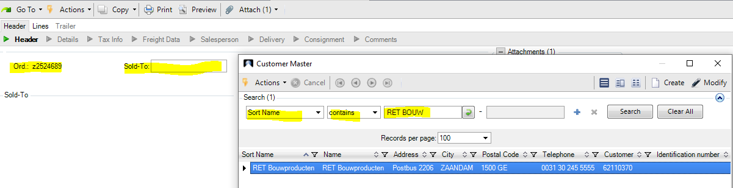

Bill to (Bill to party, in the most cases the same as Sold to party) – skip by enter
Ship to (Ship to party, can bet he same as Sold to Party, but can be oftern different)
- same Ship to party – just press enter and QAD will add it
- different Ship to party – search it as below + double click + enter
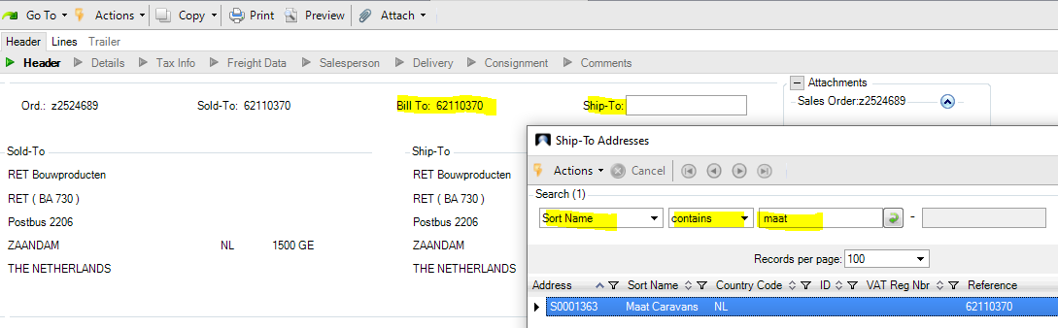
Purchase Order = use for customer´s purchase order number
Remarks = use for customer´s name + city (visible field in 51.2.2.22 Sales order lines – assistants) + enter
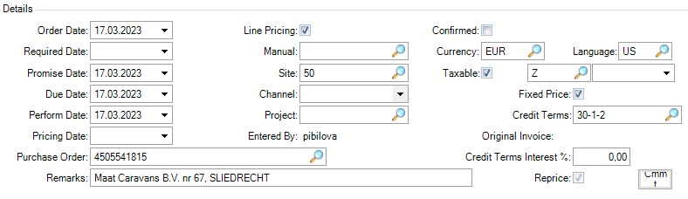

This field is automatically added by QAD = mean just HRX monthly exchange rate + skip it by enter
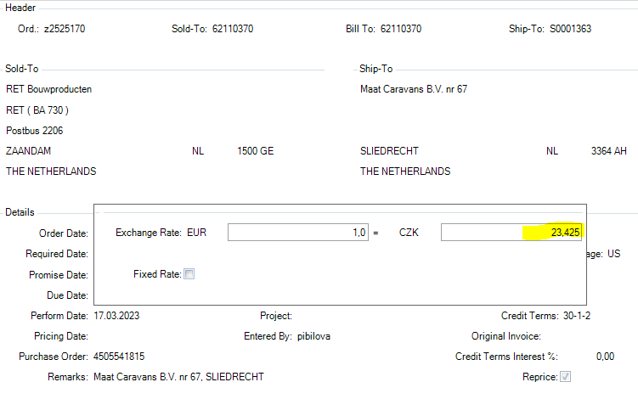
This field is automatically added by QAD – just search as below (has no impact, only needs to be filled)
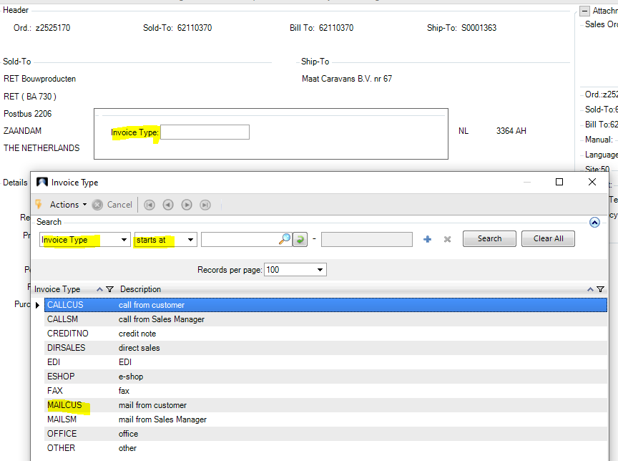

This data come from 2.1.1 Customer maintanance – skip it by enter.
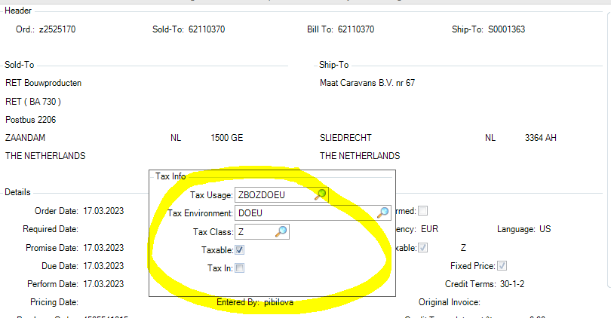

This data come from 2.1.1 Customer maintanance – skip it by enter.

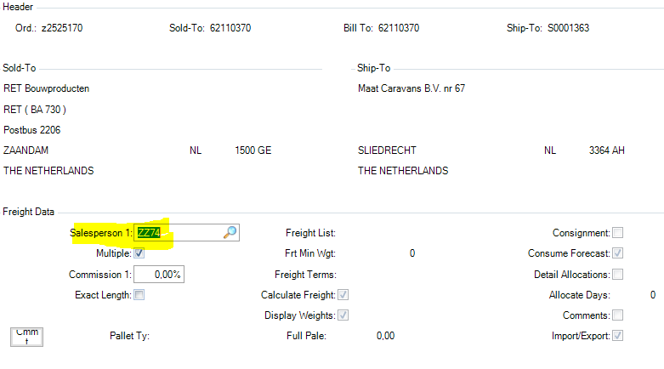

Use enter few times – below comes from 2.1.1 Customer maintanance – skip it by enter.
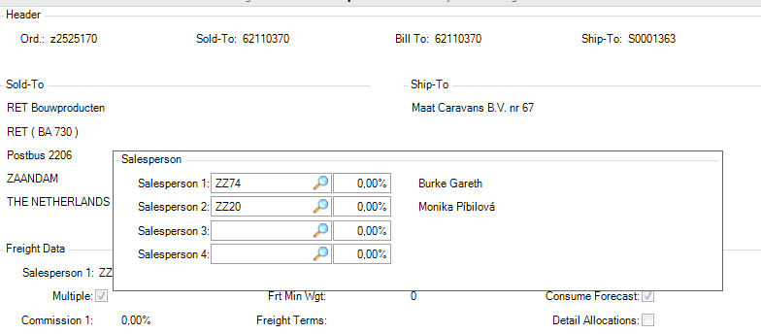

Press few enters to get here + put article number (better to search via Hranipex Article, but you can search directly from here by using searching button).
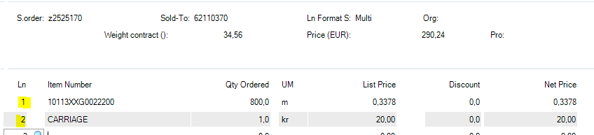

When there are all items entered + carriage (based on your price list) + 2x back and then you are as below. Press No.
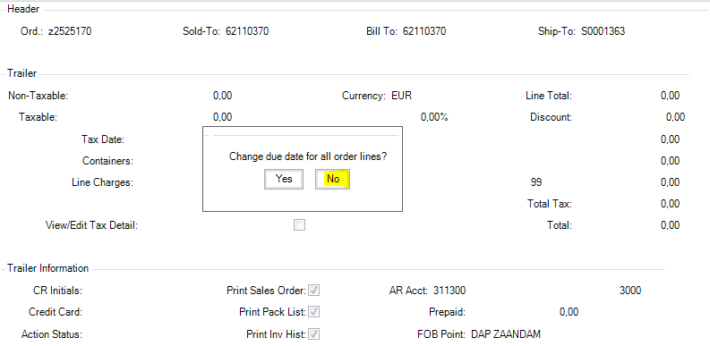
Print Sales order – after you create Sales Order Confirmation in 7.1.3 Sales Order Print, then this field will be ticked out. Means if you need to creat new OC (Order Confirmation), you have to tick it again.
FOB Point – incoterms code + delivery place (town)
Ship Via – choose a proper transport
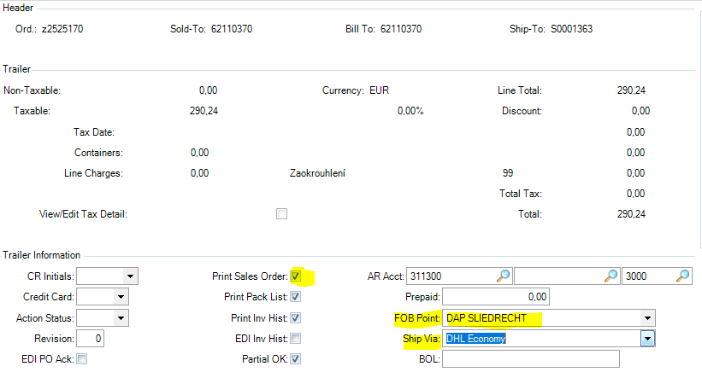

+ 3x enter and choose No as for the below screen 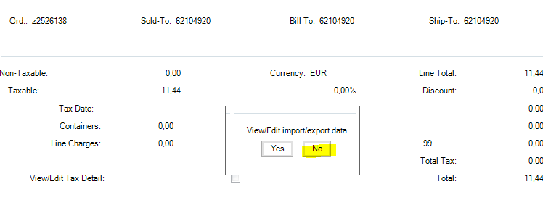

CHANGES IN THE ORDER – via 7.1.1
You can go via 7.1.1 to below screen and change the line/s.
Ln: Put position to maintain the line or add new position.
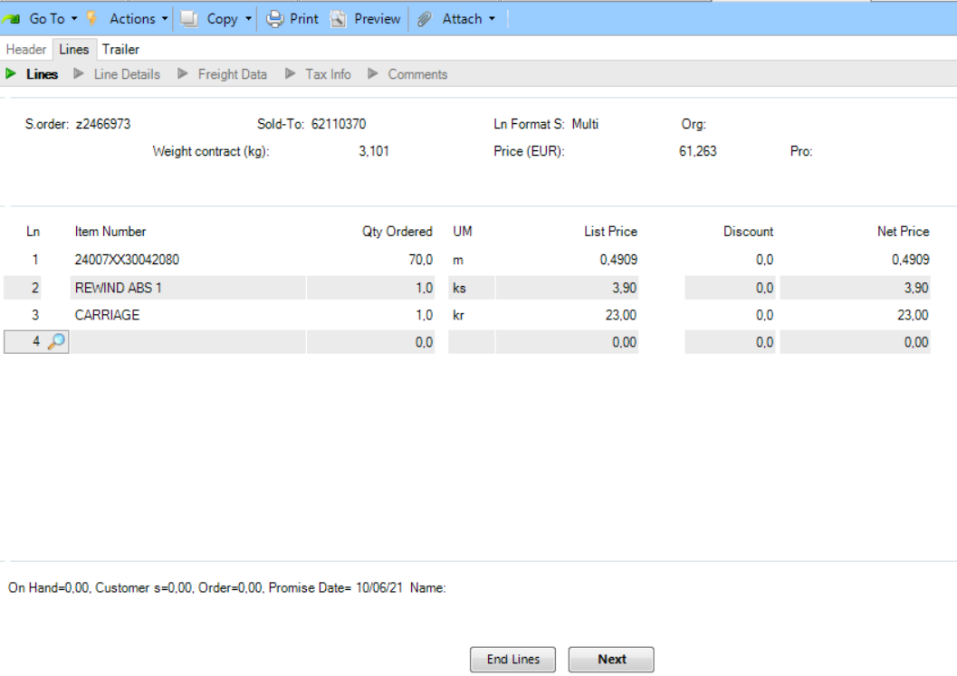

CHANGES IN THE ORDER – via 51.2.2.22 Sales order lines – assistents
You can change your order directly from this function via Edit SO (just press this button).
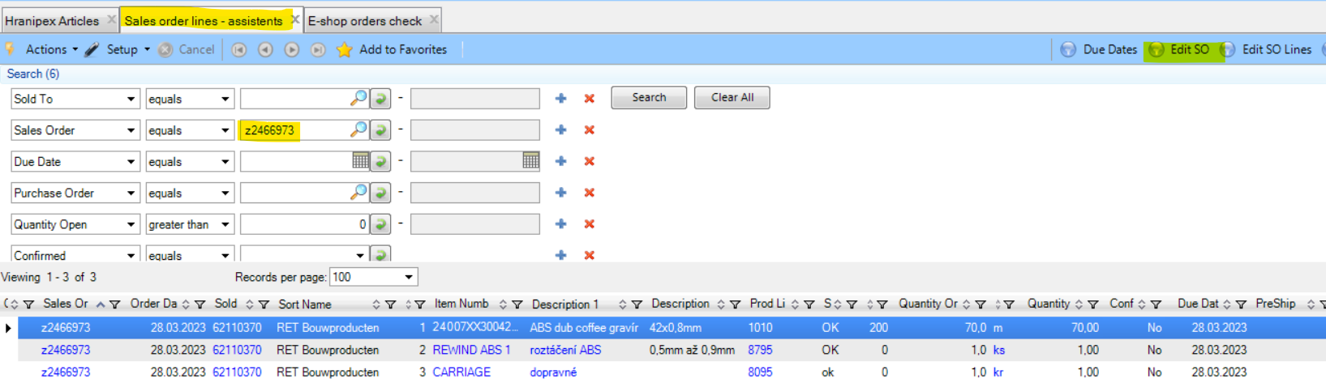

Then you are redirected to 7.2.1 Hranipex job data maintenance (modified version of 7.1.1).
The fields are here rewritable, so you can do here whatever you need.
+ Next to confirm the changes (I want to cancel position 4. and change the Qties on position 1 from 70m to 80m)
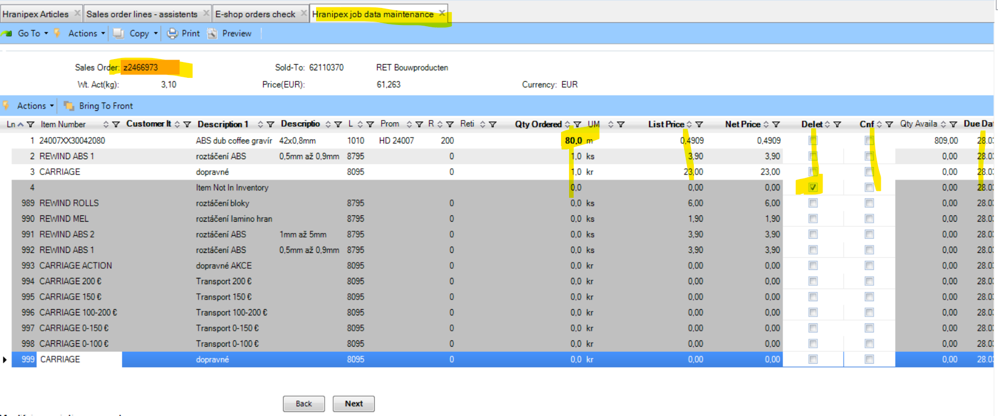

Now you can see that the Qties on position 1 was changed and position 4 was cancelled.
+ Back
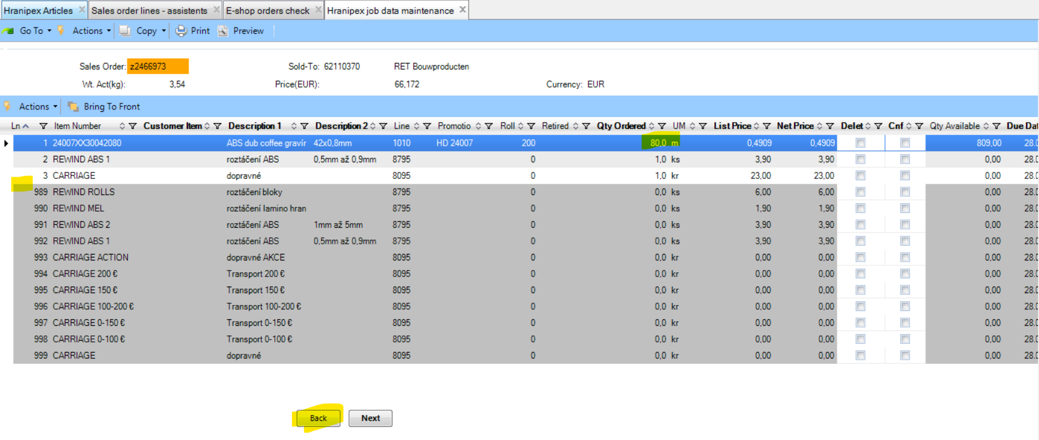

On this screen you can play a bit by using Sellection.
E.g. 7 = you can split the Qties on a position (this is only what I use here in case of need)
+ Back
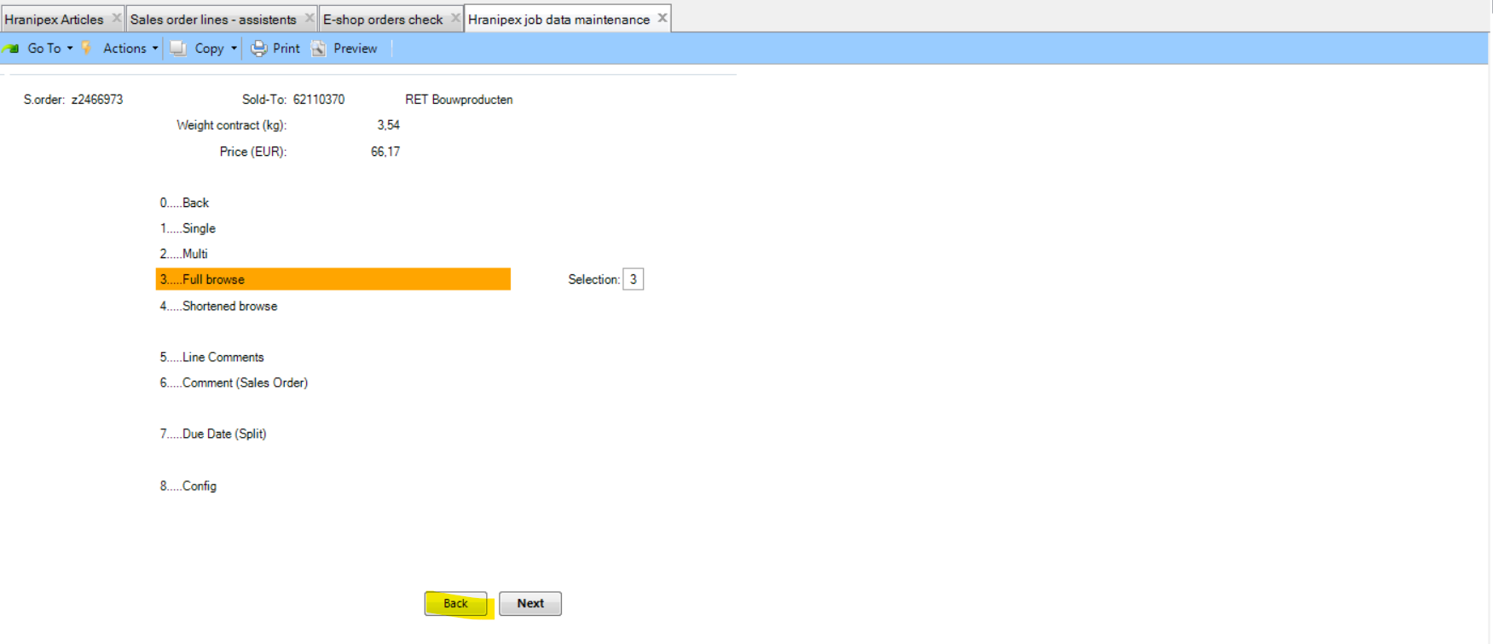
Now you are on 7.2.1 level at the end of order.
+ 4x Next
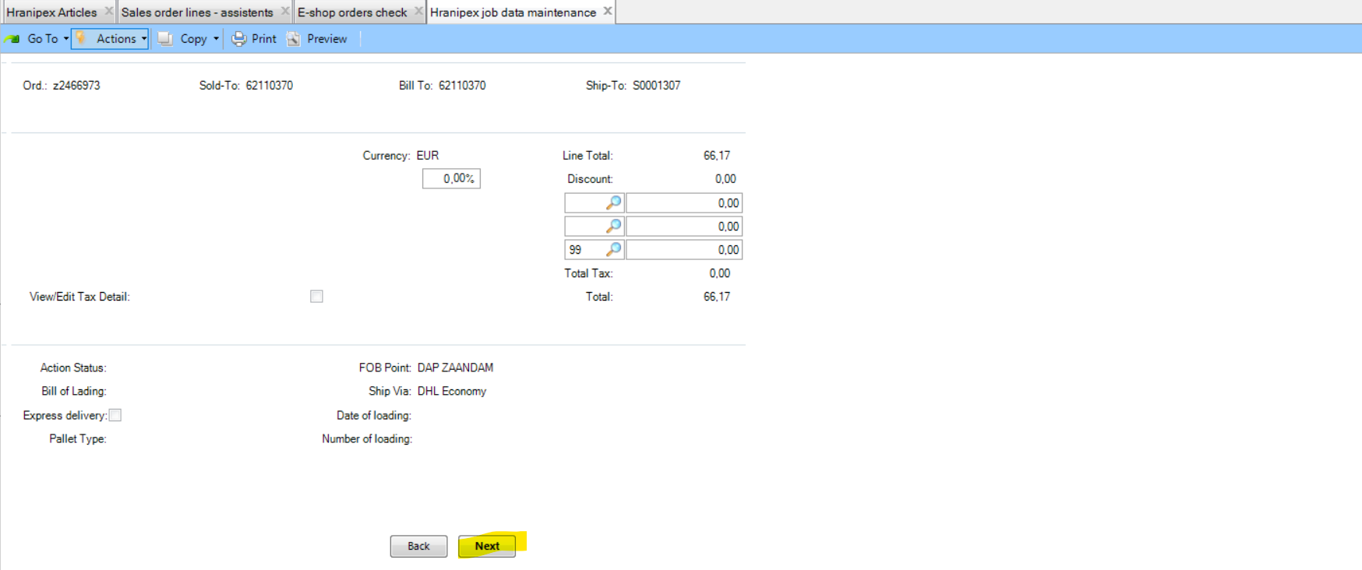

+ No
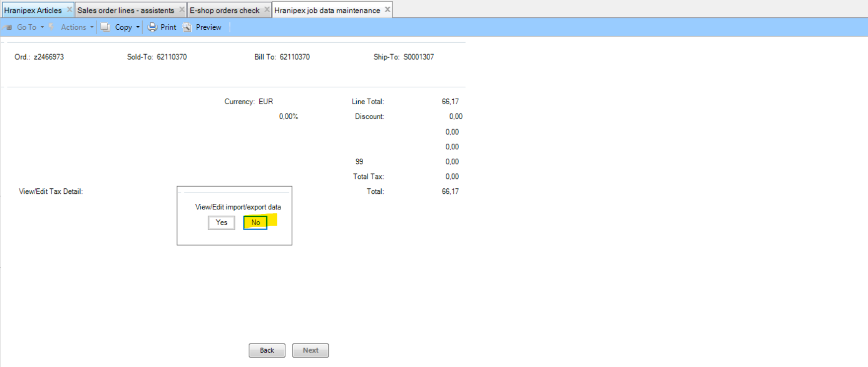

You can confirm from this window a whole order by clicking on Confirmed.
Confirmed: mark/click + Next
Confirmed: umarked/uncliked + Back
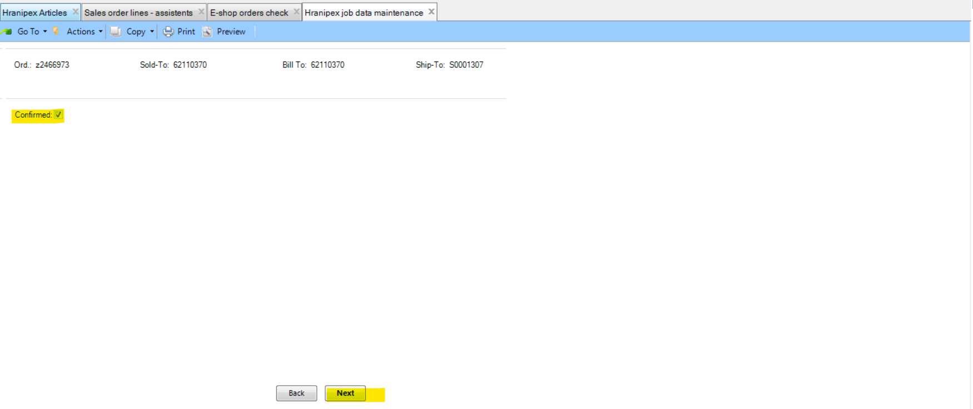

You can print OC from this window by clicking on Print Sales Order.
Print Sales Order: mark/click + Next
Print Sales Order: unmarked/unclicked + Back

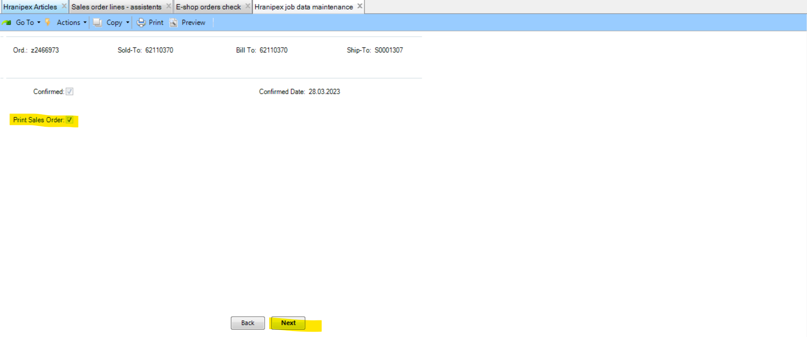

If you marked Print Sales Order then you are redirected to 7.1.3 Sales Order Print.
Print Item number: mark/click
+ Next
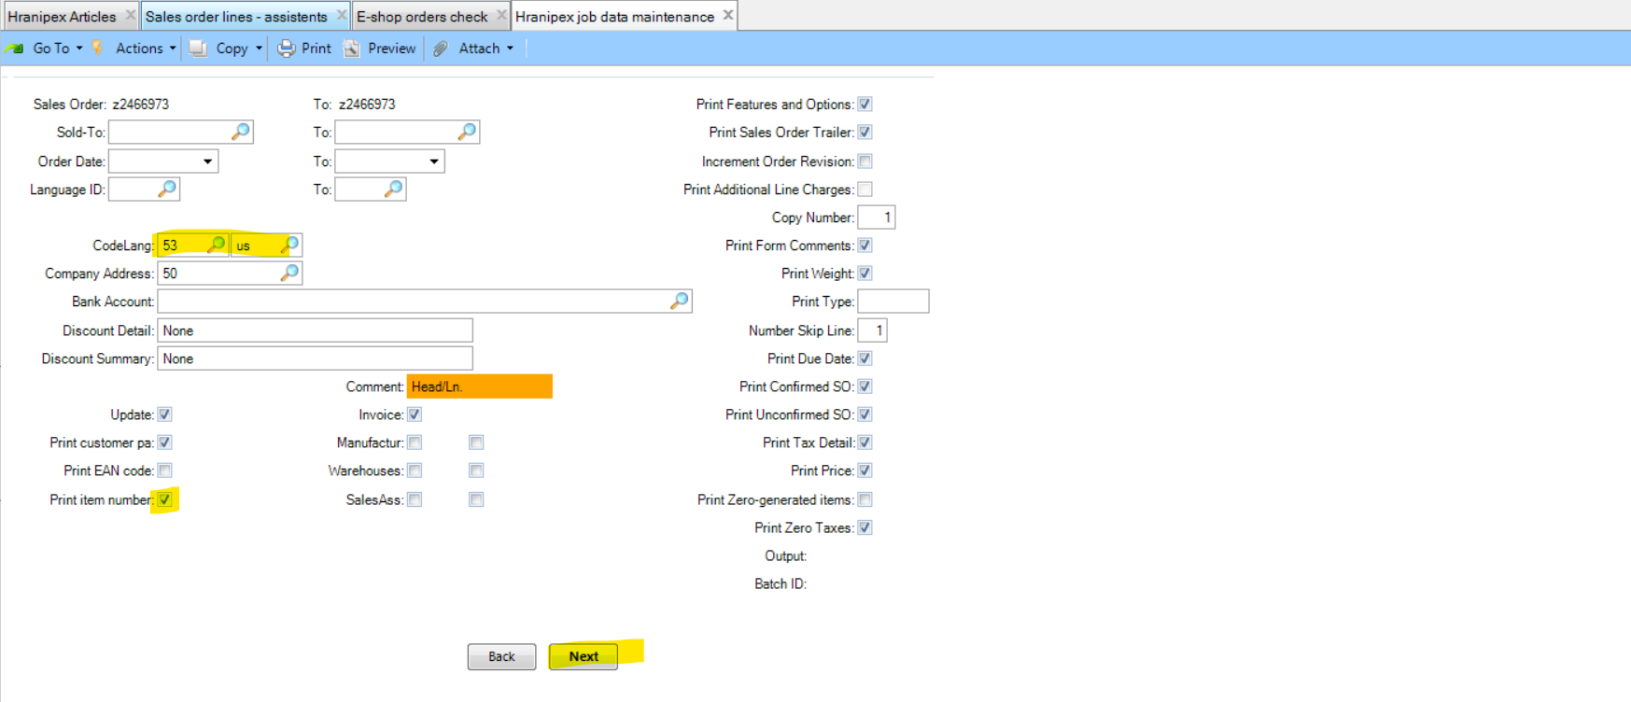

OutPut: pdf
+ Next (then OC will be sent from QAD to your mailbox)
